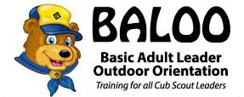

BALOO – Basic Adult Leader Outdoor Orientation

April 27-28, 2024

The goal of the BALOO training experience is to provide you with the necessary skills and confidence to venture into the great outdoors with your Cub Scouts and provide them with a great first-time camping, hiking, or any other outdoor experience. Having a BALOO trained leader is a requirement for you Pack to do any camping activities.

Check in: Saturday 8 AM
Course concludes on Sunday at 11 AM

Meals include Saturday Lunch, Supper, Cracker Barrel and Sunday Breakfast.
This is an overnight event so pack accordingly including a tent. Please contact Kyle if special accommodations are needed and we will do our best to make this a positive learning experience.

Register at: www.samoset.org/events

